


Gargoyles to Gables
Honeycomb to Spider’s Silk

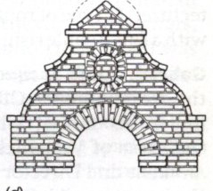
St. Christopher’s Annual Heritage Open Days
Saturday & Sunday
20/21 September.
&
Harvest Festival Service

A celebration of architecture in its various forms. Do visit, you’ll be fascinated. Architecturally themed floral displays in the beautiful St. Christopher’s church. Refreshments and produced stall in churchyard.

Saturday 20 September: 10.00 - 16.00,
Ringing 11.00,
Church tour 14.00.

Sunday 21 September: 10.30 - 16.00,
Harvest Festival service 9.30,
Church tour 14.00,
Ringing 15.30.
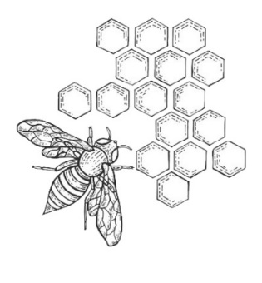



Donations to the church running costs are gratefully received.

