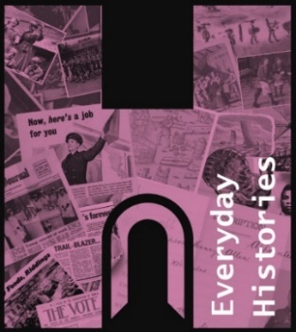


Village Life in Victorian Willingale

St. Christopher’s Annual Heritage Open Days
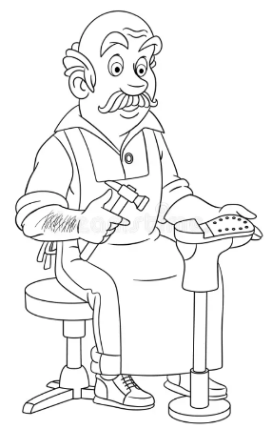
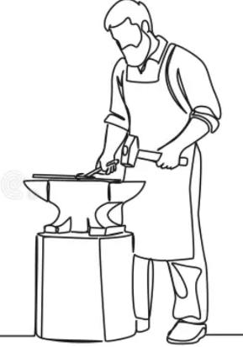
Saturday & Sunday
19/20 September.
&
Harvest Festival Service

A celebration of the trades and crafts in years gone by that made the village self-sufficient. Do visit, you’ll be fascinated and then walk around the village to imagine people at work and where they lived. Try your hand at bell ringing. Refreshments and produced stall in churchyard. St. Christopher’s church CM5 0SJ.

Saturday 20 September: 10.00 - 16.00,
Ringing try-out and demo throughout the day
Ringing 10.00,
Church tour 14.00.

Sunday 21 September: 10.30 - 16.00,
Harvest Festival service 9.30,
Ringing try-out and demo throughout the day
Church tour 14.00.
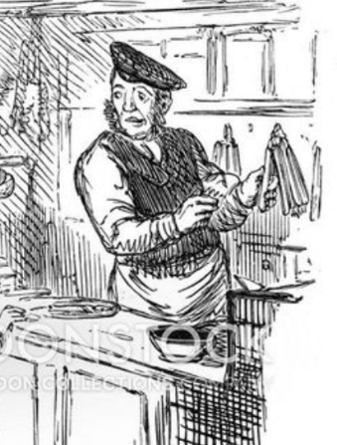

Ringing 15.30


Donations to the restoration of church stained glass.

